SOFTWARE DESIGN DOCUMENT

Table Of Contents

1.0 INTRODUCTION 3

1.1 Purpose 3

1.2 Scope 3

***1.2.1 Objectives*** 4

1.3 System Description 4

1.4 Overview 4

1.5 Reference Material 4

1.6 Definitions and Acronyms 5

2.0 SYSTEM OVERVIEW 5

3.0 SYSTEM ARCHITECTURE 6

3.2 Decomposition Description 7

3.3 Design Rationale 8

4.0 DATA DESIGN 9

4.1 Data Description 9

4.2 Logical Design 10

5.0 COMPONENT DESIGN 10

6.0 HUMAN INTERFACE DESIGN 11

6.1 Overview of User Interface 11

6.2 Screen Objects and Actions 12

7.0 REQUIREMENTS MATRIX 13

Table 7.1 Requirements Matrix 13

**List Of Tables**

Table 1.5.1: Definitions and Acronyms 5

*Table 4.2.1 logical design of customer information* 10

Table 5.1 Summary of algorithms and pseudocode 11

**List Of Figures**

Figure 2.0.1 A generalized overview of how the user interacts with the NSSF Customer Support Data Analysis system 6

Figure 3.1.1 Architectural Design 7

Figure 3.2.1 Context diagram of dataflow 8

Figure 3.2.2 Level 0 diagram for dataflow 8

Figure 6.1 The main Interface of the system which acts as the main page 12

Figure 6.2 Bar graph visualization as a result of data from uploaded csv file 13

Figure 6.3 The line-chart visualization of data 13

# 1.0 INTRODUCTION

The NSSF customer support data analysis project is meant to provide full analysis of how operators interact with the clients on the NSSF online customer support system. The results of this analysis will be used by management to improve their services to the customers.

## 1.1 Purpose

The purpose of the Software Design Document is to provide a full description of the design of the software to allow software development to proceed with an understanding of what is to be built and how it is expected to be built.

It also provides information necessary for the description of the details for the software to be built.

## 1.2 Scope

1. **NSSF project manager:** The NSSF systems administrator is going to use this analysis report to find flaws in the customer support system and forward it to the top level administrators for decision making on how to improve it.
2. **NSSF systems Administrator:** The NSSF systems administrator is mainly meant to maintain the proposed system once it is in operation.
3. **System Scope:** The results of this analysis is going to provide a report on how the system users (NSSF customers) and the NSSF workers (operators) interact with the current customer support system.

### ***1.2.1 Objectives***

* To provide an analysis of the most commonly asked questions and how to answer them as quickly as possible.
* To help NSSF executives find out the most visited page and the corresponding questions asked on the NSSF Online Customer Support System.
* To determine the time when there are many incoming requests and provide advice on how to handle those requests by the correct number of operators.
* To provide an analysis of the average number of clients to the online customer support system per day and give suggestions on how to provide better services to them.
* To find out if the customers get the exact help they need from the NSSF online operators.

## 1.3 System Description

The system will be configured to receive input data from a csv file which contains customer information including their Id, email, phone numbers and other information.

In addition, the system performs tasks such as data visualization from the uploaded CSV file in the form of charts of different formats including pie-charts, bar-charts, line-charts and other various formats

## 1.4 Overview

This document is divided into sections each of which gives a clear description of part of the NSSF Customer Support Data Analysis System. Given below is a short description of each of the sections and their subsections.

* **The introduction:** This provides a detailed description of the purpose, scope and objectives of the NSSF Customer Support Data Analysis System.
* **The System Overview:** This section gives a general description of the functionality and context of the NSSF Customer Support Data Analysis System.
* **The System Architecture:** This section provides a detailed description of all components and modules that make up the complete system.

It also describes various design implementations used during the development of the system.

* Other sections include the data design section which describes how data is manipulated to produce the desired results and the component design which provides a summary of algorithms of each of the functions of the system.

## 1.5 ***Reference Material***

[1] [www.nssfug.org](http://www.nssfug.org), NSSF Customer Service Charter, 2017.

[Online]. Available: [www.nssfug.org/20/Resources/Customer_Service_Charter](http://www.nssfug.org/20/Resources/Customer_Service_Charter).

[2] <http://www.cs.mu.oz.au> Introduction to UML: Structural Modelling and Use Cases, 2000

[3] <http://www.SoftwareEngineering-9.com> Software Engineering by Ian Sommerville

[4] <http://www.wiley.com/college/dennis> System_Analysis_Design_UML5th Dennis Wixom Roth

## 1.6 ***Definitions and Acronyms***

## Table 1.5.1: Definitions and Acronyms

|  |  |
| --- | --- |
| Term | Definition |
| Software Design Document | A document that completely describes all of the functions of a proposed system and the constraints under which it must operate |
| NSSF | National Social Security Fund |
| IEEE | Institute of Electrical And Electronics Engineers |
| CSV | ***Comma Separated Values*** |

# 2.0 SYSTEM OVERVIEW

Generally, the system will allow users to upload a CSV file. The uploaded file shall be used to show the most frequently asked questions by NSSF clients using a word cloud or any other visualization technique as may be needed.

The uploaded file shall also be used to provide an average number of customers to the NSSF Customer Support System over a period of one month.

The uploaded data will also be used to provide a prediction of how many clients might visit the NSSF Customer Support System over a specified amount of time.

The results of this analysis will be used by the NSSF executives to find out what needs to be worked upon immediately in order to improve the services it offers to the people.

**Below is a generalised overview of how the user interacts with the NSSF Customer Support Data Analysis system.**

Results returned to the user

User

## Figure 2.0.1 A generalized overview of how the user interacts with the NSSF Customer Support Data Analysis system

3.0 SYSTEM ARCHITECTURE3.1 Architectural Design

The proposed system is a customer support data analysis system.

The architecture used for the system is a Client/Server Architecture where a client can use Internet browsers to access the analyzed data.

The user first acquires access by logging in into the system.

The system has the interface which contains:

* Login section: this provides access to the user into the system.
* Upload section: this is where the file with data is uploaded from
* Display section: this is where the charts showing analyzed data are displayed.

The user (project manager) upload the file which contains data to be analyzed.

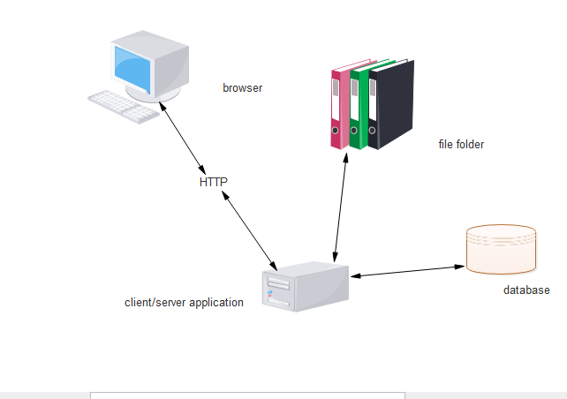

## Figure 3.1.1 Architectural Design

## 3.2 Decomposition Description

**Context diagram showing the flow of data**

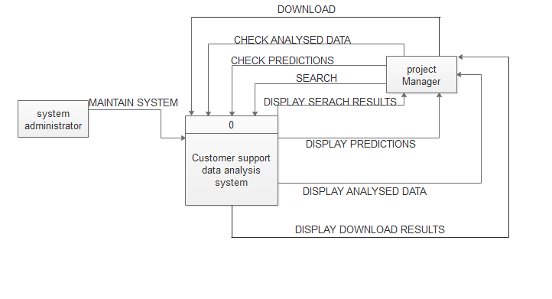

## Figure 3.2.1 Context diagram of dataflow

**Level 0 diagram for dataflow**

Manager: the system manager accesses permission into the system by logging in. He then uploads the file that contains data to be analyzed.

The analyzed data is then displayed in form of charts.

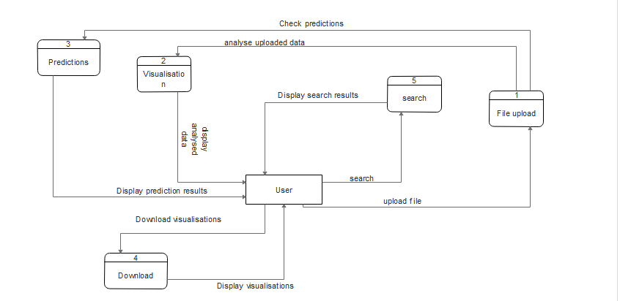

## Figure 3.2.2 Level 0 diagram for dataflow

## 3.3 Design Rationale

We selected client/server architecture because there is a request made by the browser (client) to upload the file. The file is uploaded as the way of servicing the request from the client.

# 4.0 DATA DESIGN

This section is about the persistent data management. Persistent data management deals with how the persistent data (file, database, etc) are stored and managed and it outlives a single execution of the system.

Information related to user, customer and other basic information is persistent data and hence stored in a CSV file. This allows all the programs that operate on the NSSF customer support system data to work consistently.

## 4.1 Data Description

This involves listing different entities and their attributes and then identifying relationships between them.

**Top level management:** These are the ones that view the analysed data and decide the future of the customer service department by finding the solution to the problems and improve on the services offered by the department

**Operator**: These are the providers of the data that is going to be manipulated by the system which is collected from the website of NSSF. This data is collected from the NSSF customer support database and then the reports that are generated after are exported to a CSV file.

**Administrator:** This is the customer service manager who gets the csv file and then imports it into the system so that it can be diagnosed into simpler formats like bar graphs, pie-charts and word cloud, and they can always browse another csv file as long as it has the same column headings as the imported file and will be able to download the different pages in either png, pdf and print them out.

## 4.2 Logical Design

In order to upload and display information persistently we map objects into tables and the attributes into fields to the specific table based on the objects found on the system.

We shall upload the data to be analysed from a csv file.

# *Table 4.2.1 logical design of customer information*

**Data_to_be_analyzed**

|  |  |  |  |  |  |  |  |
| --- | --- | --- | --- | --- | --- | --- | --- |
| X{P.K} | X.1 | ID | Visitor.Name | E.mail | Phone | Wait.time | Country |

|  |  |  |  |  |  |  |
| --- | --- | --- | --- | --- | --- | --- |
| City | IP | Operator | Department | Date | Minutes | Vote.status |

|  |  |
| --- | --- |
| Mail.send | Page |

# 5.0 COMPONENT DESIGN

This section provides a summary of some of the algorithms and pseudocode that were used to develop each component of the NSSF Customer Support Data Analysis system.

## Table 5.1 Summary of algorithms and pseudocode

|  |  |
| --- | --- |
| **COMPONENT** | **PSEDUDOCODE** |
| FILE UPLOAD | Click browse and select file  IF (file is CSV)  THEN file is uploaded successfully  ELSE  File failed to upload  ENDIF |
| VISUALIZATION | IF (CSV is uploaded)  THEN Navigate the dashboard  IF (chart is selected)  THEN display chart data  ELSE  Select chart again  ELSE  Upload CSV file again  ENDIF |
| PREDICTIONS | IF(File is uploaded)  THEN Click predictions button  THEN SELECT Charts  ELSE  Upload the file again  ENDIF |
| SEARCH | Type the keyword  IF (keyword found )  THEN Display search results  ELSE  Display empty dashboard  ENDIF |
| DOWNLOAD | Click download button  IF (File Exists)  THEN Display success message  ELSE  Download failed  ENDIF |

# 6.0 HUMAN INTERFACE DESIGN

We are going to design this system using shiny package and shiny dashboard package.

Shiny is an open source web application framework for R, developed by R studio. It makes it easy to turn analytical analysis into stylish, interactive web apps, presentable to a wider audience. And it seems the best option since our goal is to design and implement a presentable web application.

In R using shiny we create the user interface which is an R file. This is where we control layout, appearance and widgets that capture user inputs and also display the output are to be included here. That shall include the graphs, radio buttons, the title etc.

We also create a server file which is an R file for computation purpose. It contains a set of instructions that uses the input provided by the user, processes them and produces the required output which is displayed by the user interface R script.

## 6.1 Overview of User Interface

The User Interface is a crucial aspect of the system in terms of both what the client wants and needs. For this reason, there is an overview of the User Interface This section will detail all aspects of the User Interface and its design.

These documents also have different target audiences and aims and thus different User Interface sections are presented.

The user will be prompted with the login screen when the application starts. Once the user logs into the application successfully, the profile page of the user will be prompted to him/her according to the user type.

## 6.2 Screen Objects and Actions

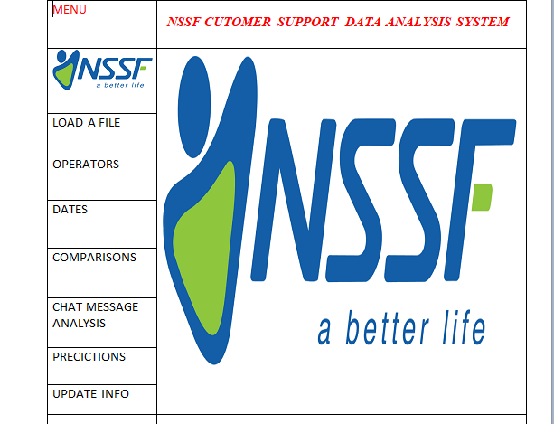

## Figure 6.1 The main Interface of the system which acts as the main page

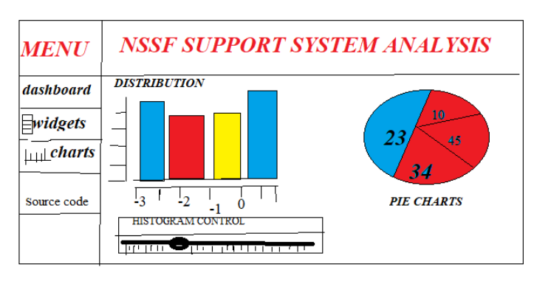

## Figure 6.2 ***Bar graph visualization as a result of data from uploaded csv file***

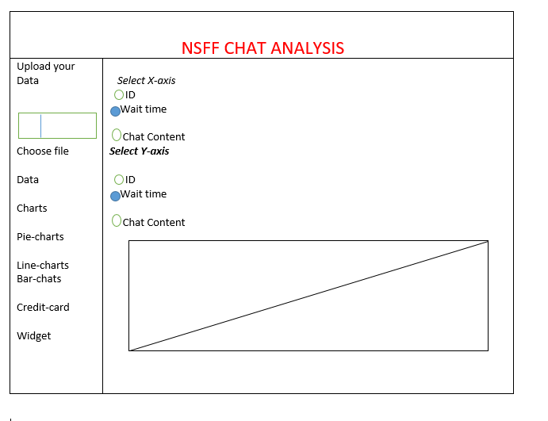

## Figure 6.3 The line-chart visualization of data

# 7.0 REQUIREMENTS MATRIX

|  |  |  |  |  |  |
| --- | --- | --- | --- | --- | --- |
| **Components:**  **Requirements from SRS**  **(use cases):** | **Download**  **component** | **Search component** | **Upload File** | **Analyse Uploaded Data** | **Display Analysed Data** |
| UC |  |  |  |  |  |

UC stands for use case.

## Table 7.1 Requirements Matrix